Assignment 4
CSA05 Database Management Systems – CO4 (Set 2): Bank Transaction Log – Storage, Indexing and Hashing (MySQL)

Queries

A. Create database and tables (one table per storage strategy)
- CREATE DATABASE IF NOT EXISTS bank_co4;
- USE bank_co4;
- -- Strategy 1: heap file (no key, no index) - every search is a full scan
CREATE TABLE txn_heap (
txn_id BIGINT NOT NULL,
account_no CHAR(12) NOT NULL,
txn_time DATETIME NOT NULL,
txn_type CHAR(1) NOT NULL,
amount DECIMAL(12,2) NOT NULL,
branch VARCHAR(20) NOT NULL,
channel VARCHAR(10) NOT NULL,
narration VARCHAR(80),
balance DECIMAL(12,2) NOT NULL,
other VARCHAR(45)
);
- -- Strategy 2: clustered B+ Tree on txn_id (InnoDB primary key)
CREATE TABLE txn_btree (
txn_id BIGINT NOT NULL,
account_no CHAR(12) NOT NULL,
txn_time DATETIME NOT NULL,
txn_type CHAR(1) NOT NULL,
amount DECIMAL(12,2) NOT NULL,
branch VARCHAR(20) NOT NULL,
channel VARCHAR(10) NOT NULL,
narration VARCHAR(80),
balance DECIMAL(12,2) NOT NULL,
other VARCHAR(45),
PRIMARY KEY (txn_id)
);
- -- Strategy 3: hash organisation on txn_id (MEMORY engine, hash index)
SET max_heap_table_size = 536870912;
- CREATE TABLE txn_hash (
txn_id BIGINT NOT NULL,
account_no CHAR(12) NOT NULL,
txn_time DATETIME NOT NULL,
txn_type CHAR(1) NOT NULL,
amount DECIMAL(12,2) NOT NULL,
branch VARCHAR(20) NOT NULL,
channel VARCHAR(10) NOT NULL,
narration VARCHAR(80),
balance DECIMAL(12,2) NOT NULL,
other VARCHAR(45),
PRIMARY KEY (txn_id) USING HASH
) ENGINE=MEMORY;
- -- helper table of digits 0-9 used to generate the dataset
CREATE TABLE digits (d INT PRIMARY KEY);
- SHOW TABLES;

B. Load the dataset (10,00,000 transactions, same data in every strategy)
- INSERT INTO digits VALUES (0),(1),(2),(3),(4),(5),(6),(7),(8),(9);
- INSERT INTO txn_heap
SELECT (d1.d + 10*d2.d + 100*d3.d + 1000*d4.d + 10000*d5.d + 100000*d6.d) + 1,
CONCAT('ACC', LPAD(1 + (d1.d + 10*d2.d + 100*d3.d + 1000*d4.d + 10000*d5.d + 100000*d6.d) % 50000, 9, '0')),
CONCAT('2026-10-01 ', LPAD(FLOOR((d1.d + 10*d2.d + 100*d3.d + 1000*d4.d + 10000*d5.d + 100000*d6.d) / 3600) % 24, 2, '0'), ':',
LPAD(FLOOR((d1.d + 10*d2.d + 100*d3.d + 1000*d4.d + 10000*d5.d + 100000*d6.d) / 60) % 60, 2, '0'), ':', LPAD((d1.d + 10*d2.d + 100*d3.d + 1000*d4.d + 10000*d5.d + 100000*d6.d) % 60, 2, '0')),
CASE WHEN (d1.d + 10*d2.d + 100*d3.d + 1000*d4.d + 10000*d5.d + 100000*d6.d) % 2 = 0 THEN 'D' ELSE 'C' END,
((d1.d + 10*d2.d + 100*d3.d + 1000*d4.d + 10000*d5.d + 100000*d6.d) % 9000) + 100.25,
CONCAT('BR', LPAD(1 + (d1.d + 10*d2.d + 100*d3.d + 1000*d4.d + 10000*d5.d + 100000*d6.d) % 25, 2, '0')),
CASE (d1.d + 10*d2.d + 100*d3.d + 1000*d4.d + 10000*d5.d + 100000*d6.d) % 4 WHEN 0 THEN 'UPI' WHEN 1 THEN 'ATM' WHEN 2 THEN 'NEFT' ELSE 'BRANCH' END,
'Transaction narration', 50000.00 + ((d1.d + 10*d2.d + 100*d3.d + 1000*d4.d + 10000*d5.d + 100000*d6.d) % 1000), 'reserved'
FROM digits d1 CROSS JOIN digits d2 CROSS JOIN digits d3
CROSS JOIN digits d4 CROSS JOIN digits d5 CROSS JOIN digits d6
ORDER BY 1;
- INSERT INTO txn_btree SELECT * FROM txn_heap ORDER BY txn_id;
- INSERT INTO txn_hash SELECT * FROM txn_heap;

C. Row counts for dataset sizes 1,000 / 10,000 / 1,00,000 / 10,00,000
- SELECT 'txn_heap' AS strategy, SUM(txn_id <= 1000) AS n_1000, SUM(txn_id <= 10000) AS n_10000,
SUM(txn_id <= 100000) AS n_100000, COUNT(*) AS n_1000000 FROM txn_heap
UNION ALL
SELECT 'txn_btree', SUM(txn_id <= 1000), SUM(txn_id <= 10000), SUM(txn_id <= 100000), COUNT(*) FROM txn_btree
UNION ALL
SELECT 'txn_hash', SUM(txn_id <= 1000), SUM(txn_id <= 10000), SUM(txn_id <= 100000), COUNT(*) FROM txn_hash;

D. Task 3 and 5 – Cost formulas computed in SQL (B = 4096, R = 200, key 8, block pointer 6, record pointer 8)
- -- Blocking factor bfr = FLOOR(B/R), blocks b = CEIL(r/bfr)
SELECT FLOOR(4096/200) AS bfr, CEIL(1000000/FLOOR(4096/200)) AS blocks_b,
CEIL(CEIL(1000000/FLOOR(4096/200)) / 2) AS heap_avg_search,
CEIL(1000000/FLOOR(4096/200)) AS heap_worst_search,
CEIL(LOG2(CEIL(1000000/FLOOR(4096/200)))) AS binary_search_sorted;
- -- Sparse primary index on txn_id: entry = key + block pointer = 14 bytes
SELECT FLOOR(4096/14) AS index_bfr,
CEIL(50000/FLOOR(4096/14)) AS level1_blocks,
CEIL(CEIL(50000/FLOOR(4096/14))/FLOOR(4096/14)) AS level2_blocks,
2 + 1 AS block_accesses_multilevel_sparse;
- -- Dense secondary index on account_no: entry = 12 + 8 = 20 bytes, one entry per record
SELECT FLOOR(4096/20) AS index_bfr,
CEIL(1000000/FLOOR(4096/20)) AS level1_blocks,
CEIL(CEIL(1000000/FLOOR(4096/20))/FLOOR(4096/20)) AS level2_blocks,
CEIL(CEIL(CEIL(1000000/FLOOR(4096/20))/FLOOR(4096/20))/FLOOR(4096/20)) AS level3_blocks;
- -- Order of B-Tree (p*6 + (p-1)*(8+8) <= 4096) and B+ Tree internal / leaf nodes
SELECT FLOOR((4096 + 16) / 22) AS btree_order_p,
FLOOR((4096 + 8) / 14) AS bplus_internal_order_p,
FLOOR((4096 - 6) / 16) AS bplus_leaf_entries;
- -- B+ Tree capacity at 69% fill: fan-out 202, leaf entries 175
SELECT 202 * 175 AS capacity_2_levels,
202 * 202 * 175 AS capacity_3_levels,
202 * 202 * 202 * 175 AS capacity_4_levels;
- -- Static hashing: buckets for 10,00,000 records at load factor 0.8 (bucket = 1 block, 20 records)
SELECT CEIL(1000000 / (20 * 0.8)) AS primary_buckets,
ROUND(1000000 / CEIL(1000000 / (20 * 0.8)), 2) AS avg_records_per_bucket,
CEIL(2000 / 20) AS blocks_for_2000_row_range_in_ordered_file;

E. Task 5 – Build secondary indexes for AccountNo and Branch
- CREATE INDEX idx_account ON txn_btree (account_no);
- CREATE INDEX idx_branch ON txn_btree (branch);
- -- txn_heap keeps no index, so account and branch look-ups are full scans there

F. Task 8 – Equality, range, non-key look-ups return identical results in every strategy
- -- Dispute desk: equality search on TxnID (heap = scan, B+ Tree = index, hash = bucket)
SELECT txn_id, account_no, amount, branch FROM txn_heap WHERE txn_id = 500000;
- SELECT txn_id, account_no, amount, branch FROM txn_btree WHERE txn_id = 500000;
- SELECT txn_id, account_no, amount, branch FROM txn_hash WHERE txn_id = 500000;
- -- Hourly reconciliation: range of 2,000 TxnIDs
SELECT 'txn_heap' AS strategy, COUNT(*) AS rows_found, MIN(txn_id) AS first_id, MAX(txn_id) AS last_id
FROM txn_heap WHERE txn_id BETWEEN 500001 AND 502000
UNION ALL
SELECT 'txn_btree', COUNT(*), MIN(txn_id), MAX(txn_id)
FROM txn_btree WHERE txn_id BETWEEN 500001 AND 502000
UNION ALL
SELECT 'txn_hash', COUNT(*), MIN(txn_id), MAX(txn_id)
FROM txn_hash WHERE txn_id BETWEEN 500001 AND 502000;
- -- Non-key equality on AccountNo (secondary index vs scan)
SELECT 'txn_heap' AS strategy, COUNT(*) AS txns FROM txn_heap WHERE account_no = 'ACC000012345'
UNION ALL
SELECT 'txn_btree', COUNT(*) FROM txn_btree WHERE account_no = 'ACC000012345'
UNION ALL
SELECT 'txn_hash', COUNT(*) FROM txn_hash WHERE account_no = 'ACC000012345';
- -- Audit: non-key equality on Branch
SELECT 'txn_heap' AS strategy, COUNT(*) AS txns FROM txn_heap WHERE branch = 'BR07'
UNION ALL
SELECT 'txn_btree', COUNT(*) FROM txn_btree WHERE branch = 'BR07'
UNION ALL
SELECT 'txn_hash', COUNT(*) FROM txn_hash WHERE branch = 'BR07';
- SELECT branch, COUNT(*) AS txns FROM txn_btree GROUP BY branch ORDER BY branch LIMIT 5;

G. Task 8 – Boundary cases (empty file, duplicate keys, deleting the last key)
- -- Empty file
CREATE TABLE txn_empty (txn_id BIGINT PRIMARY KEY, account_no CHAR(12) NOT NULL);
- SELECT * FROM txn_empty WHERE txn_id = 1;
- SELECT COUNT(*) AS records, MAX(txn_id) AS last_key FROM txn_empty;
- INSERT INTO txn_empty VALUES (1,'ACC000000001');
- -- Duplicate key: heap accepts it silently (no key), B+ Tree and hash reject it
INSERT INTO txn_heap VALUES (500,'ACC000000500','2026-10-01 00:08:19','D',100.25,'BR01','UPI','Duplicate test',500.00,'x');
- SELECT txn_id, COUNT(*) AS copies FROM txn_heap WHERE txn_id = 500 GROUP BY txn_id;
- DELETE FROM txn_heap WHERE txn_id = 500 AND narration = 'Duplicate test';
- INSERT INTO txn_btree VALUES (500,'ACC000000500','2026-10-01 00:08:19','D',100.25,'BR01','UPI','Duplicate test',500.00,'x');
- INSERT INTO txn_hash VALUES (500,'ACC000000500','2026-10-01 00:08:19','D',100.25,'BR01','UPI','Duplicate test',500.00,'x');
- -- Deleting the last key
DELETE FROM txn_btree WHERE txn_id = 1000000;
- SELECT COUNT(*) AS records, MAX(txn_id) AS last_key FROM txn_btree;
- INSERT INTO txn_btree SELECT * FROM txn_heap WHERE txn_id = 1000000;
- SELECT COUNT(*) AS records, MAX(txn_id) AS last_key FROM txn_btree;

H. Task 12 – UPI gateway: random 64-bit style TxnID, 2,00,000 inserts in one hour
- -- Redesign: append-only file ordered by arrival (seq) + unique index on gateway id + time index
CREATE TABLE txn_upi (
seq BIGINT AUTO_INCREMENT PRIMARY KEY,
gateway_txn_id BIGINT NOT NULL,
account_no CHAR(12) NOT NULL,
txn_time DATETIME NOT NULL,
amount DECIMAL(12,2) NOT NULL,
branch VARCHAR(20) NOT NULL
);
- CREATE UNIQUE INDEX uk_gateway ON txn_upi (gateway_txn_id);
- CREATE INDEX idx_upi_time ON txn_upi (txn_time);
- INSERT INTO txn_upi (gateway_txn_id, account_no, txn_time, amount, branch)
SELECT ((n * 1103515245 + 12345) % 2147483647) * 4294967 + ((n * 214013 + 2531011) % 4294967),
CONCAT('ACC', LPAD(1 + n % 50000, 9, '0')),
CONCAT('2026-11-14 10:', LPAD(FLOOR(n % 3600 / 60), 2, '0'), ':', LPAD(n % 60, 2, '0')),
(n % 9000) + 100.25, CONCAT('BR', LPAD(1 + n % 25, 2, '0'))
FROM (SELECT (d1.d + 10*d2.d + 100*d3.d + 1000*d4.d + 10000*d5.d + 100000*d6.d) AS n FROM digits d1 CROSS JOIN digits d2 CROSS JOIN digits d3
CROSS JOIN digits d4 CROSS JOIN digits d5 CROSS JOIN digits d6) g
WHERE n < 200000
ORDER BY n;
- SELECT COUNT(*) AS upi_rows, COUNT(DISTINCT gateway_txn_id) AS distinct_ids FROM txn_upi;
- -- Keys are no longer increasing: count adjacent arrivals whose id goes DOWN
SELECT COUNT(*) AS out_of_order_pairs
FROM txn_upi a JOIN txn_upi b ON b.seq = a.seq + 1
WHERE b.gateway_txn_id < a.gateway_txn_id;
- -- For comparison, the bank's own increasing TxnIDs (first 2,00,000)
SELECT COUNT(*) AS out_of_order_pairs
FROM txn_btree a JOIN txn_btree b ON b.txn_id = a.txn_id + 1
WHERE a.txn_id <= 200000 AND b.txn_id < a.txn_id;
- -- Dispute look-up by gateway id uses the unique index
SELECT seq, gateway_txn_id, account_no, amount
FROM txn_upi WHERE gateway_txn_id = (SELECT gateway_txn_id FROM txn_upi WHERE seq = 123456);
- -- Hourly reconciliation: one range scan on the time index
SELECT COUNT(*) AS txns_in_hour, MIN(txn_time) AS first_txn, MAX(txn_time) AS last_txn
FROM txn_upi WHERE txn_time BETWEEN '2026-11-14 10:00:00' AND '2026-11-14 10:59:59';
- -- Rate of arrival and block-access estimate (bfr = 20, B+ Tree height 3, append-only data blocks)
SELECT 200000 AS inserts_per_hour, ROUND(200000 / 3600, 1) AS inserts_per_sec,
200000 * (3 + 1) AS bplus_random_insert_accesses,
CEIL(200000 / 20) + 200000 * (1 + 1) AS append_plus_hash_accesses;
- -- Reconciliation reads: scattered rows (1 block per row) vs time-ordered contiguous blocks
SELECT 200000 AS random_key_btree_reads, CEIL(200000 / 20) AS append_only_sequential_reads;

Outputs

A. Create database and tables (one table per storage strategy)
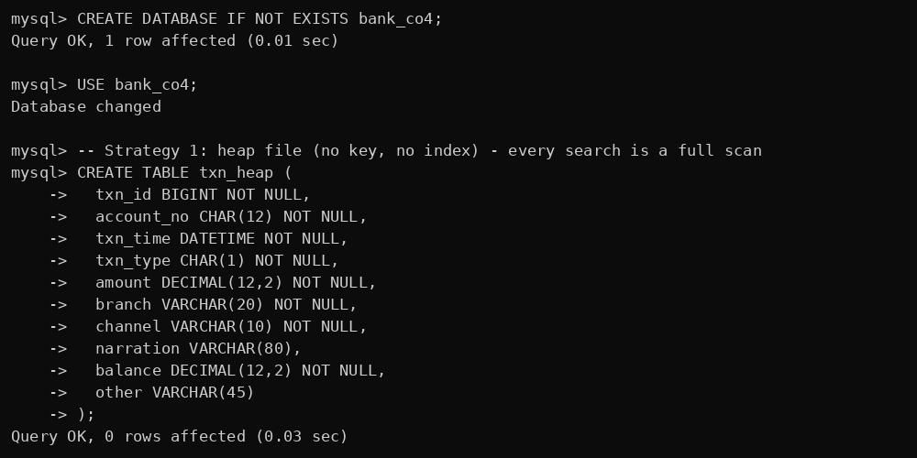
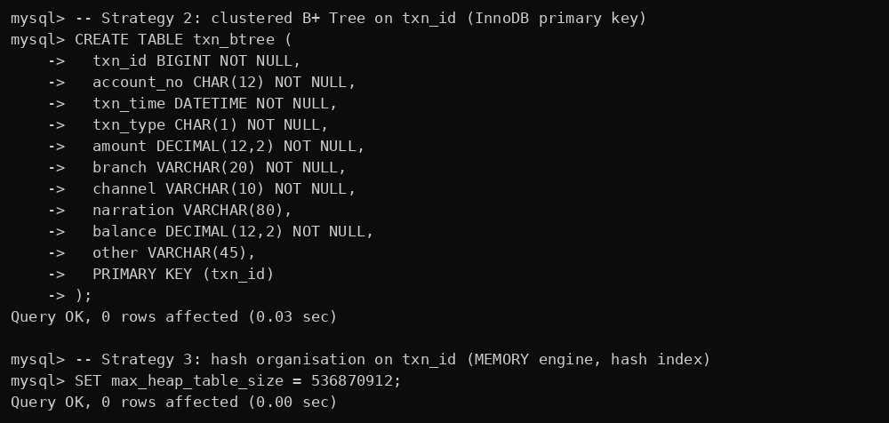
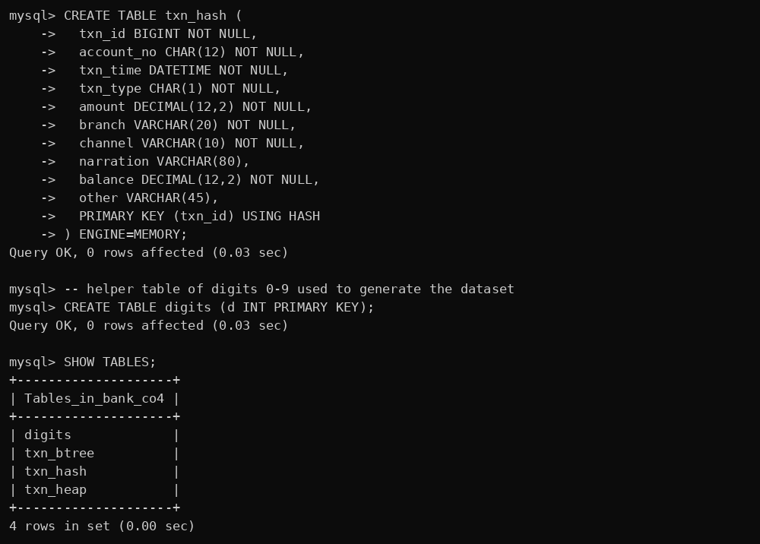

B. Load the dataset (10,00,000 transactions, same data in every strategy)
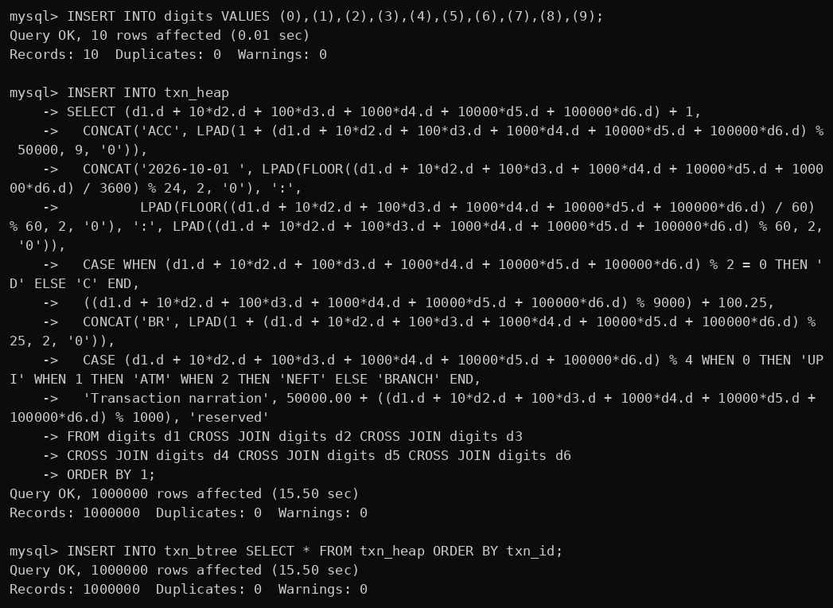

C. Row counts for dataset sizes 1,000 / 10,000 / 1,00,000 / 10,00,000
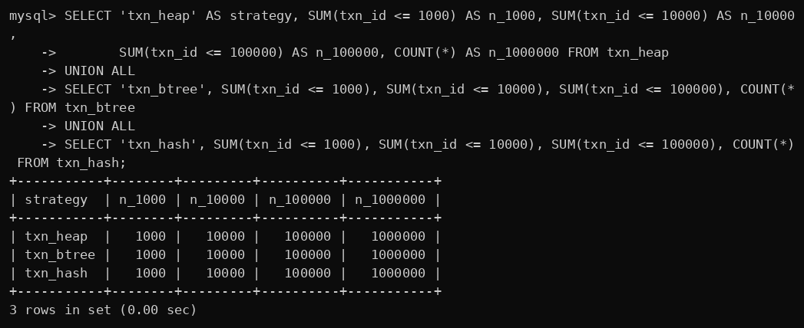

D. Task 3 and 5 – Cost formulas computed in SQL (B = 4096, R = 200, key 8, block pointer 6, record pointer 8)
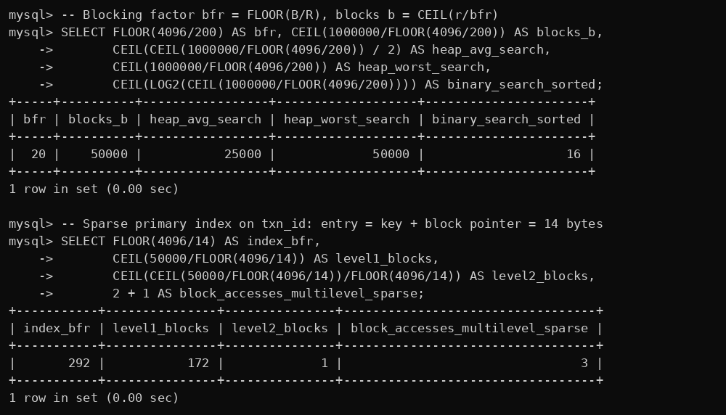
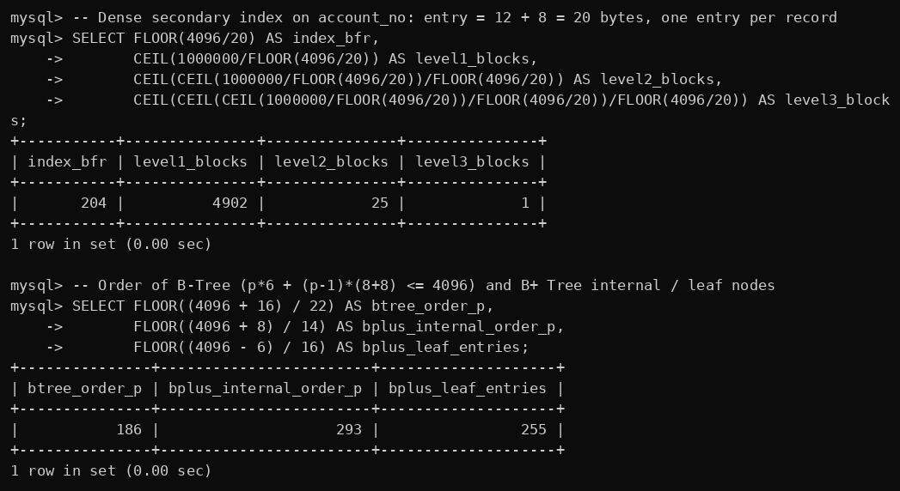
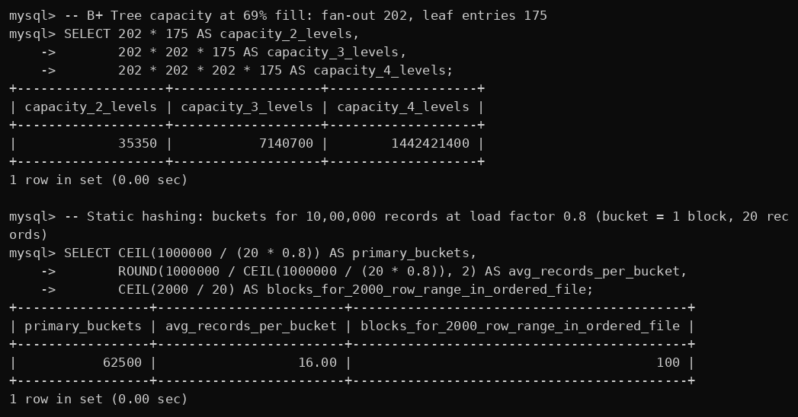

E. Task 5 – Build secondary indexes for AccountNo and Branch
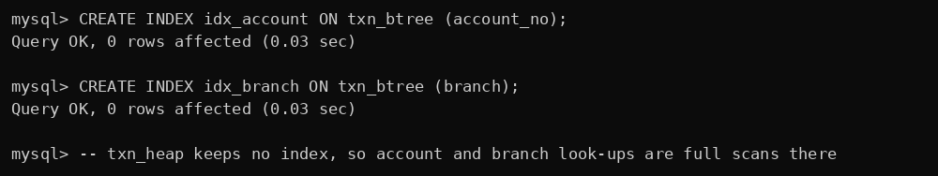

F. Task 8 – Equality, range, non-key look-ups return identical results in every strategy
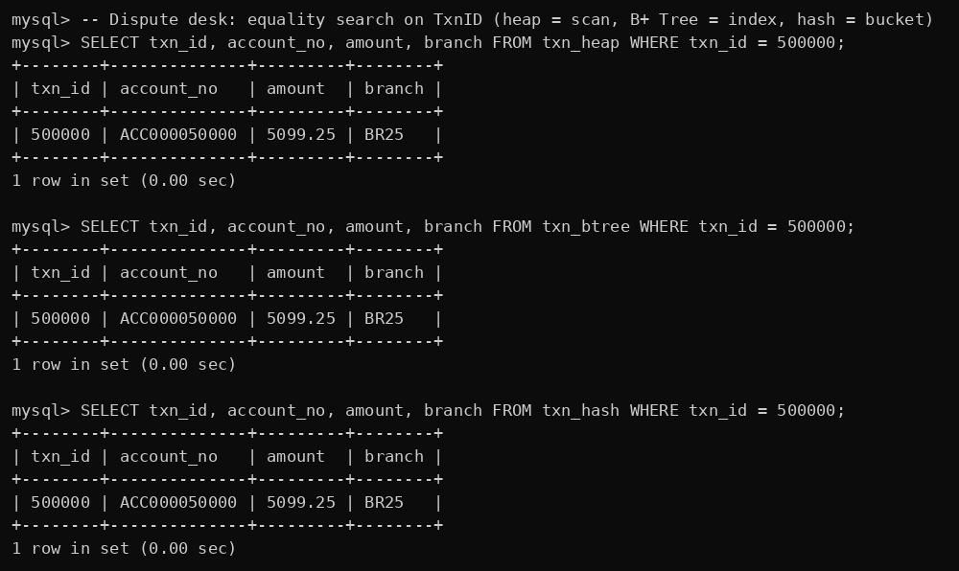
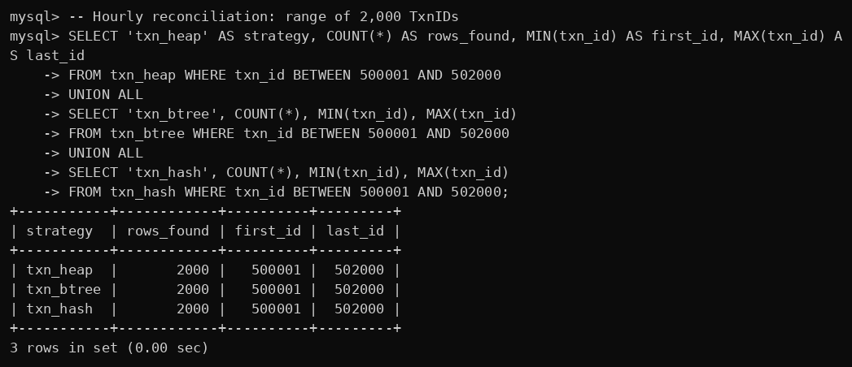
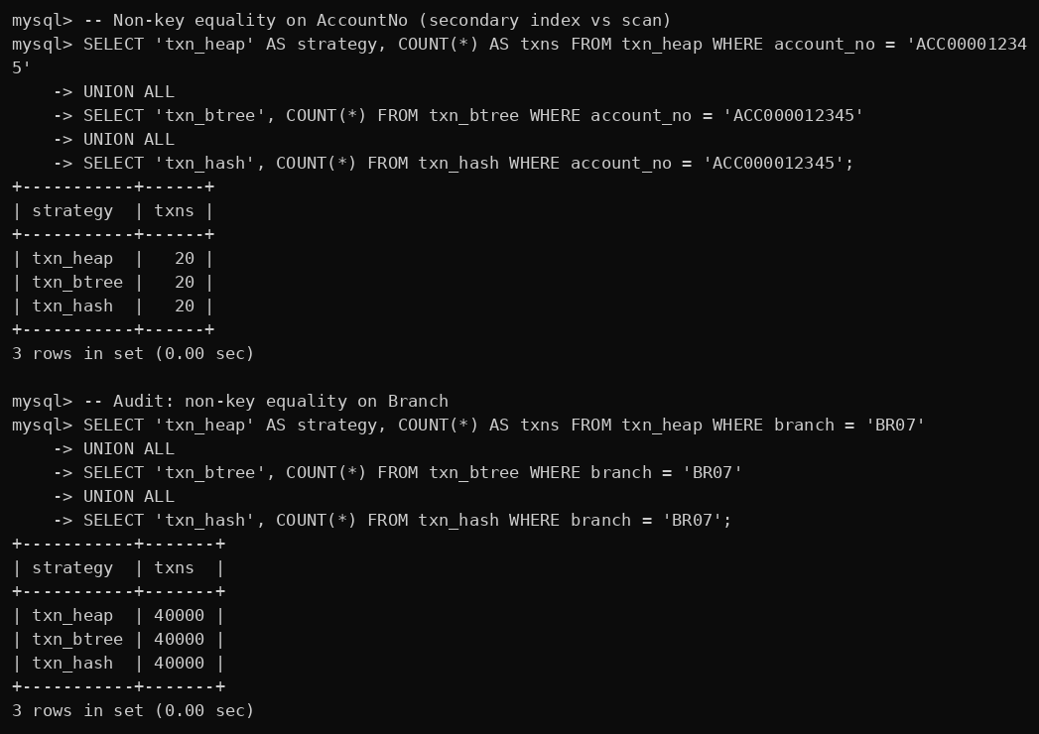
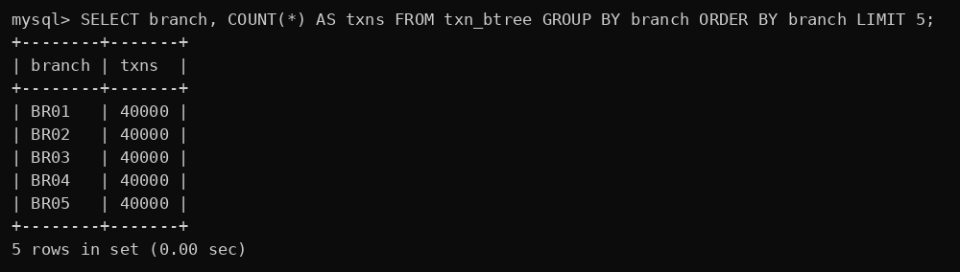

G. Task 8 – Boundary cases (empty file, duplicate keys, deleting the last key)
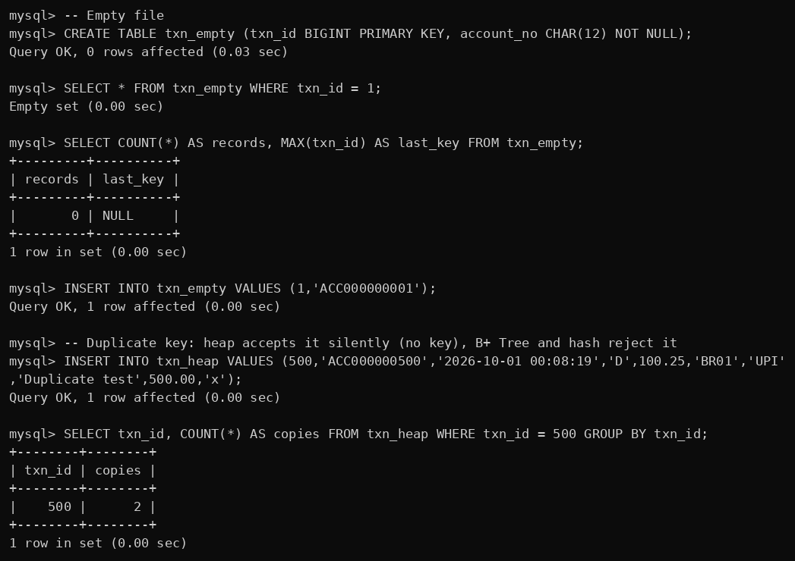
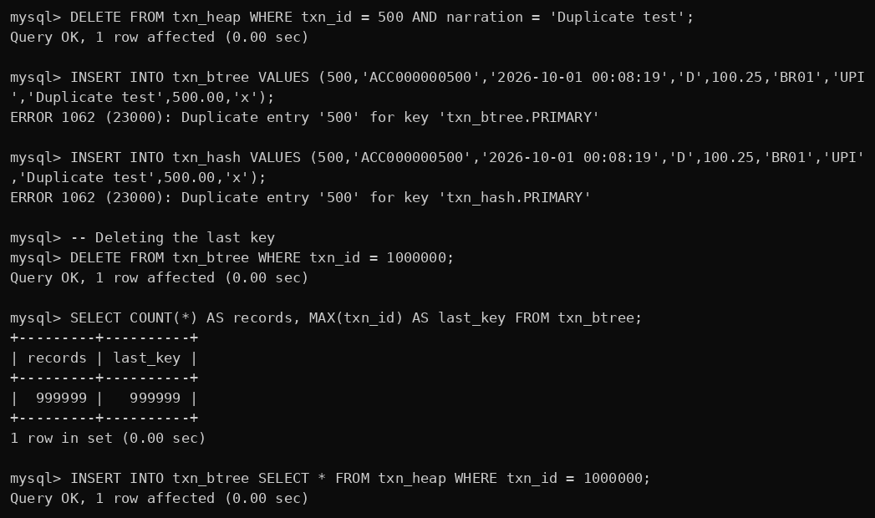
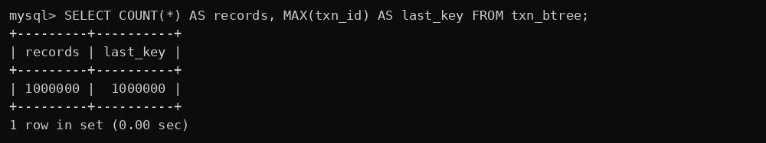

H. Task 12 – UPI gateway: random 64-bit style TxnID, 2,00,000 inserts in one hour


